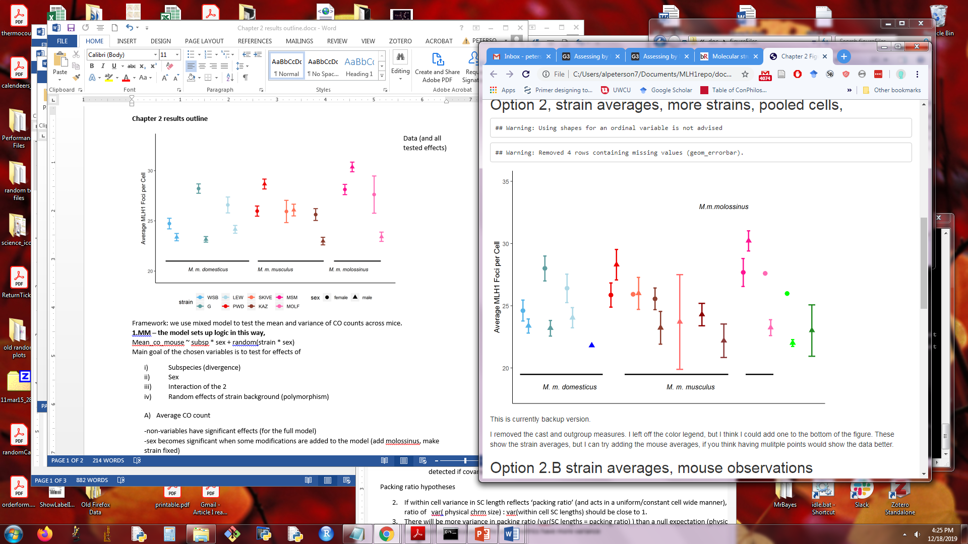**Chapter 2 results outline**

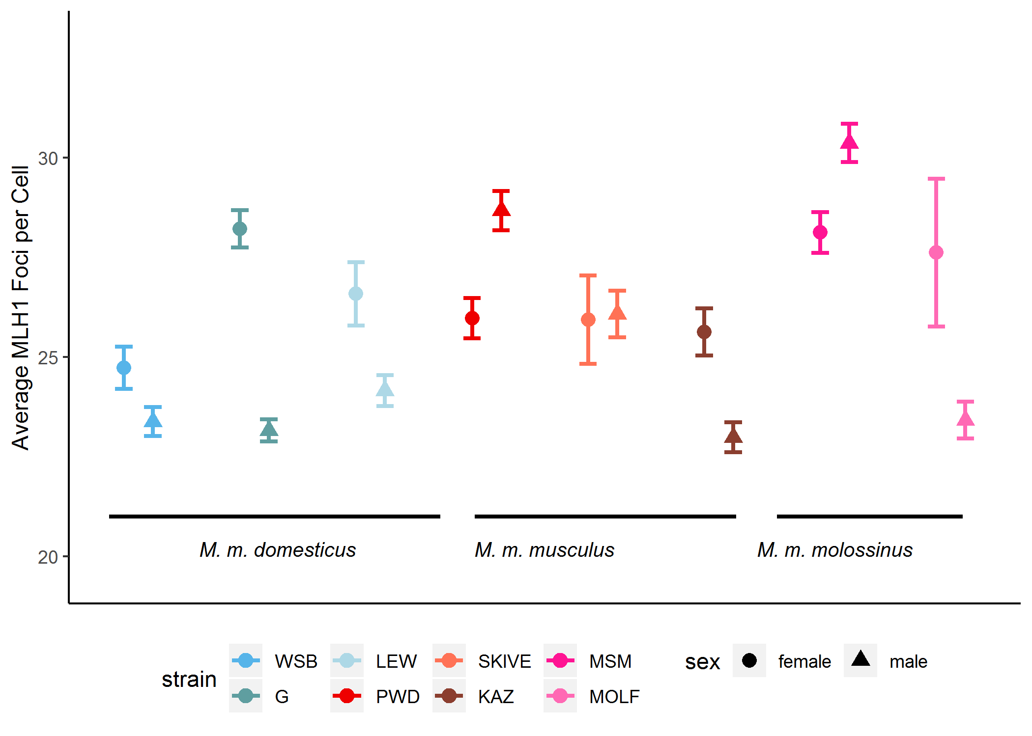

2 draft versions of Figure 1

Data (and all tested effects)

(FIND a BETTER WAY TO DISPLAY THESE main results)

Framework: we use mixed model to test the mean and variance of CO counts across mice.

**1.Mixed Model – the model was made which the following logic,**

Mean_co_mouse ~ subsp * sex + random(strain * sex)

Main goal of the chosen variables is to test for effects of

1. Subspecies (Divergence)
2. Sex
3. Interaction term
4. *Random effects* of strain background (Polymorphism)
5. Average CO count

-non-variables have significant effects (for the full model)

-sex becomes significant when some modifications are added to the model (add molossinus, make strain fixed)

the results / pvalues of variables are Not significant, but it aligns/matches qualitative pattern

-when subspecies is moved to fixed effect and nested in subsp, there are more effects

1. Variance in CO counts

-sex has a significant effect for variance

-sex is always the most significant effect, even when I adjust the model

2. Qualitative patterns

Since non-of the co-efficients tested in the model were significant, (we examine the qualitative pattern)

there is NS effects of specific subspecies or sex – we investigate Polymorphism in Musculus and molossinus

3. COs per chrm

Higher gwRR due to more 2COs per cell

SKIVE is intermediate

*most chrms are 1COs

Most dom males have 1COs

4. IFD – average placement / total SC /

-MSM and PWD have longer IFD / which can be interpreted as stronger interference.

-more space between foci on the same chromosome

4. DMC1/precursors

-precursor number can predict mean CO

**Discussion**

-table of Heterochiasmy evolution theories

-proposed functional / bivalent structure based hypotheses